**CHALLENGE PROPOSAL**

*Name of the App*: Airport Info Searcher

*Purpose*: The purpose of this App is for helping tourist to find the information of the Airport which they will use.

*Audience*: The audience in this case is for all the people who travel and sometimes they need to know more information of the airports, as is the address, a phone number, also a website.

*Data Sources:*

* External API: Airport info “<https://rapidapi.com/Active-api/api/airport-info/>”
* Local Storage: I will store the last search.
* Local JSON file: I am thinking to create a local Json for the Airport codes. I do not know how extensive it could be for all the world, but I would prefer to do just for South America.

*Initial Module list*: main.js, utilities.js info.js

*Wireframes*:

* Desktop view: <https://wireframe.cc/mrSMXJ>

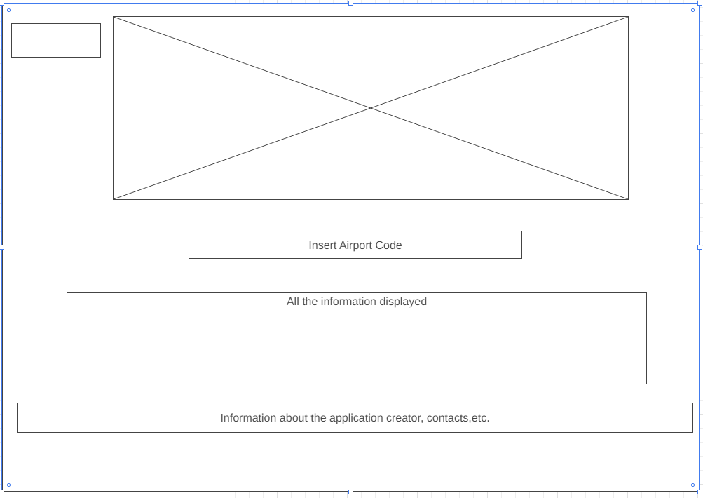

* Tablet view <https://wireframe.cc/pQ4hMC>

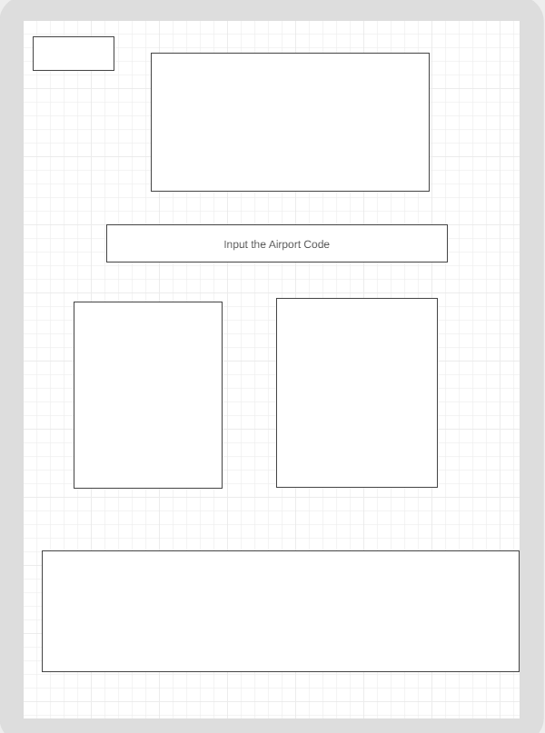

* Mobile view: <https://wireframe.cc/UKParm>

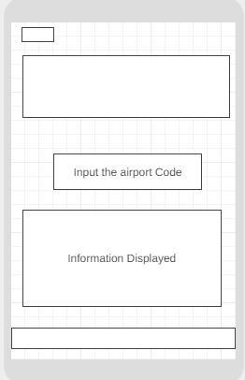

*Color Palette*



*Font Style:*

Headings: ‘Ubuntu’: <link rel="preconnect" href="https://fonts.gstatic.com">  
<link href="https://fonts.googleapis.com/css2?family=**Ubuntu:wght@500**&display=swap" rel="stylesheet">

Body Text: ‘Open Sans Condensed’ <link rel="preconnect" href="https://fonts.gstatic.com">  
<link href="https://fonts.googleapis.com/css2?family=**Open+Sans+Condensed:wght@300**&display=swap" rel="stylesheet">